Glass Report and Findings

Archaeological Methods/Theory AN-3571

Marcus Dennehy

| Type of Glass | Amount | Date (A.D.) | Description |
| --- | --- | --- | --- |
|  |  |  |  |
| Pattern Molded | 1 | 1800-1830 | A shard of light azul glass. The pattern seems to have been molded to create a snake like pattern on the top rim of the glass. The lines explain the process of the expanded lines of the glass pattern. |
| Snap-case | 1 | 1857- | Snap case bottle with a simmer of iridescence. The fully intact bottle has the words "WOODBURY N.J." inscribed on the side. |
| Snap-case | 1 | 1857- | Another snap case bottle. Words "Carter" inscribed on the base. |
| Snap-case | 1 | 1857- | Similar snap case bottle. No words except abbreviation N.Y. on the side of the bottle. |
| Screw Top closure | 3 | 1858- | Multiple similar intact screw top with a milk glass bottle. |
| Pattern Molded | 4 | 1800-1830 | Multiple shards of pharmaceutical glass. |
| Snap-case | 7 | 1857- | Multiple shards of medicinal glass. Words "VERMOTT" inscribed on the sides. |
| Screw top closure | 2 | 1857- | Two mason bottle tops without the bottle. |
| Case gin bottle | 12 | 1650-1850 | Old green tinted bottle. Multiple bubbles are seen formed within the shard pieces. Unique shaped pontil or metal mold in the base of the bottle. |
| Lamp Chimney | 2* | 1859- | Two distinctly different shaped chimney rim shards. One being twice the size as the other, the ridges being deeper in the bigger one. |
| Cut glass | 15 |  | Multiple shards of a bowl. The cut pattern is floral in pattern and seemed to be a relatively shallow bowl. |
| Turned Finish | 7 | 1880-1900 | Dark green turned finished glass. No mold marks are prevalent. Most likely was a wine bottle. |
| Decorative | 1 |  | One distinct piece of bright green decorative glass. Foggy. |

Percentage of Identified Glass 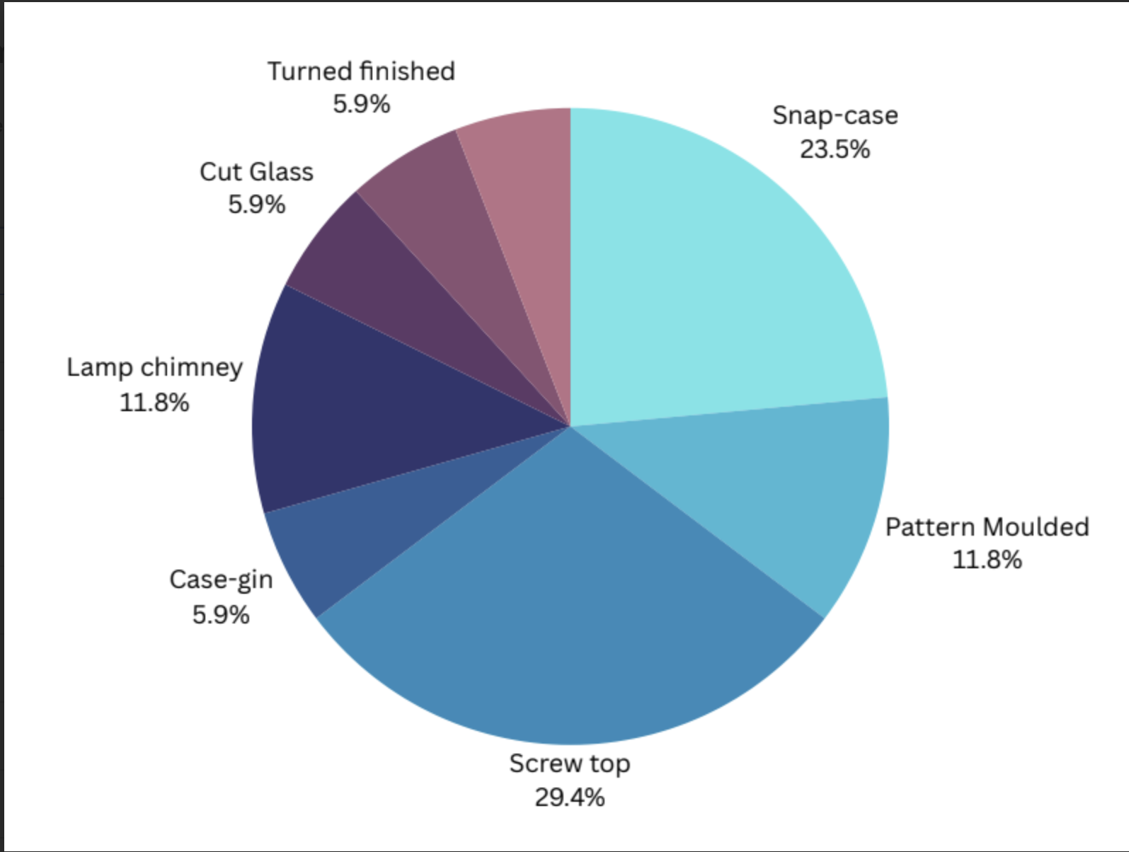

TPQ: 1900 A.D.

The youngest artifact found in the findings was a turned finish wine bottle which were prevalent until around the 1900s.

TAQ: 1650 A.D.

The oldest artifact found in the findings was a case gin bottle. Case gin bottles have bubbles in the glass, a testament to the antiquity of its craft. The findings of the shards did in fact have bubbles within the glass.

Instead of focusing on the percentage of shards, I wanted to identify what type of glass it was. The shards are important, but identifying the necks and bases will best help us identify what type of glass they are. The way it was made can explain how it was used in the Austin Family.

**Inscribed Names**

Regarding the names found on the medicinal and pharmaceutical bottles; Woodbury may be related to a still functioning hospital in New Jersey, ["Woodbury medical office"](https://www.google.com/search?q=Woodbury+medical+office&source=lmns&bih=637&biw=1252&client=safari&hl=en&sa=X&ved=2ahUKEwio2pPEuvSDAxWJobAFHb2jB8wQ0pQJKAB6BAgBEAI) 50 Cooper St, Woodbury, NJ 08096. Further research of glass bottles to further indicate if its the right address or not. The building that this Woodbury name comes from is from an old early 1800s colonial style house. So it is possible that the Austin family took the medicine from the doctors when they moved to Michigan. On google maps, further research shows possible evidence of it being a historical sight, as a ceremonious, historical plaque is placed outside the building's entrance.

Regarding the name "Carter" on the other intact snap-case bottle, research concluded little from just the name itself. The Woodbury snap-case bottle provided a origin and a use for that bottle. What is known however is that many of the snap-case bottles that were found with ambiguous names are in fact medicinal bottles. The snap case inscribed N.Y, referring to the state of New York. This concludes that the Austin family brought numerous medicinal bottles on their way to Michigan. It is possible that the Austin family may have re-used the bottles after the medicine had been used, maybe to store other types of liquid or pill-like substance.

The last of the inscriptions is from another snap case bottle with the words "Vermott". This was indeed another case of an ambiguous name and a medicinal bottle.

**Data and Percentage**

Since the recording of the data was through a type of glass identification, the percentage of different types found would be more useful information than the number of shards. The type is mostly found in the type of glass it was used for. Screw top and snap case bottles were found the most in my findings. Therefore, the percentages were a testament to the amount I identified.

**Lifestyle of the Austin Family.**

A lot of these artifacts designate a specific cultural lifestyle of the Austin family. One filled with numerous amounts of prescribed drugs, with the presence of alcohol. This is further indicated that, whether out of necessity or want, they took their medicinal bottles when migrating to Michigan. The amount of medicinal bottles could also mean that they had a sick family member, and had to take care of them on the road. For a farming family, canning jars are numerous, as it would be reasonable to use Mason patent screwtops. These jars are perfect for preserving and pickling, or just storing things in general, things a farmer would most definitely need.

Out of my findings, only about 3 cases were for status display, cut glass, decorative fog glass and chimney lamp glass with different sizes. From the findings, the relative importance is shown with the snap case liquid medicinal bottles. Only a small fraction of the findings were decorative, even alcohol was placed on lower importance compared to pill bottles or screw bottles with pills. The two different sized chimney lamps indicate there were multiple lamps on site. Possibly, multiple lamps were used simultaneously at night. I noticed from my colleagues findings of ink bottles, this could all be a testament to the medicine making people anxious or unwell. Victorian era medicine was not necessarily efficient, so it could have led to many sleepless nights.

**Gendered Artifacts**

Considering the time period and the historical context of the Austin family, it is apparent that there is evidence of gendered glass products.Screw top bottles that were made of milk glass heavily indicate the use of cosmological and perfume products. The pattern molded wine glass and the snap case medicinal bottles can imply both gender usage. This applied to women, who were allowed to use, as patented medicines had narcotics, as well as harder liquor/drugs. The social implication that the medicines were a logical necessity for both genders for the benefit of their health. This concludes that women and men in the household consumed medicine and wine. Although the case of gin bottles would be excluded only for males to drink. No women were allowed to drink hard liquor like gin in the household.

In the case of class structure, a small amount of decorative and cut bowl shards were found. These decorative glass pieces indicated wealth and prosperity. It is safe to suggest that the Austin family had numerous amounts of decorative glass.

Regarding the idea the Austin women bought more of their food than home canning; personal research has suggested otherwise. Possibly, the Austin family were more likely to use home canning, as preserving and pickling food would be more time efficient. As the Austin family lived on a farm, it would be more energy consuming and time inefficient. The types of alcohol bottles found proposed that the women drank wine and only wine. While the men were allowed both wine and hard alcohol such as gin. The screw top glasses in my findings were primarily milk glass bottles. This indicates perfume or makeup use by women. Although, the screw tops found that had no bottles intact were possibly for preserving and pickling.

To end the study, we can conclude that this site was a primary source of stock and product. This could possibly have been a pantry or kitchen. Another theory is that this was the Austin family's kitchen or dresser as these were the most common places to find medicine in the mid to late 1800s.

This site of the kitchen is most assuredly associated with the female gender. As women in this time were the ones tasked with cooking, cleaning, and providing food and health to guests and family alike.